Growing in Faith
A Series of Studies for New and Growing Christians
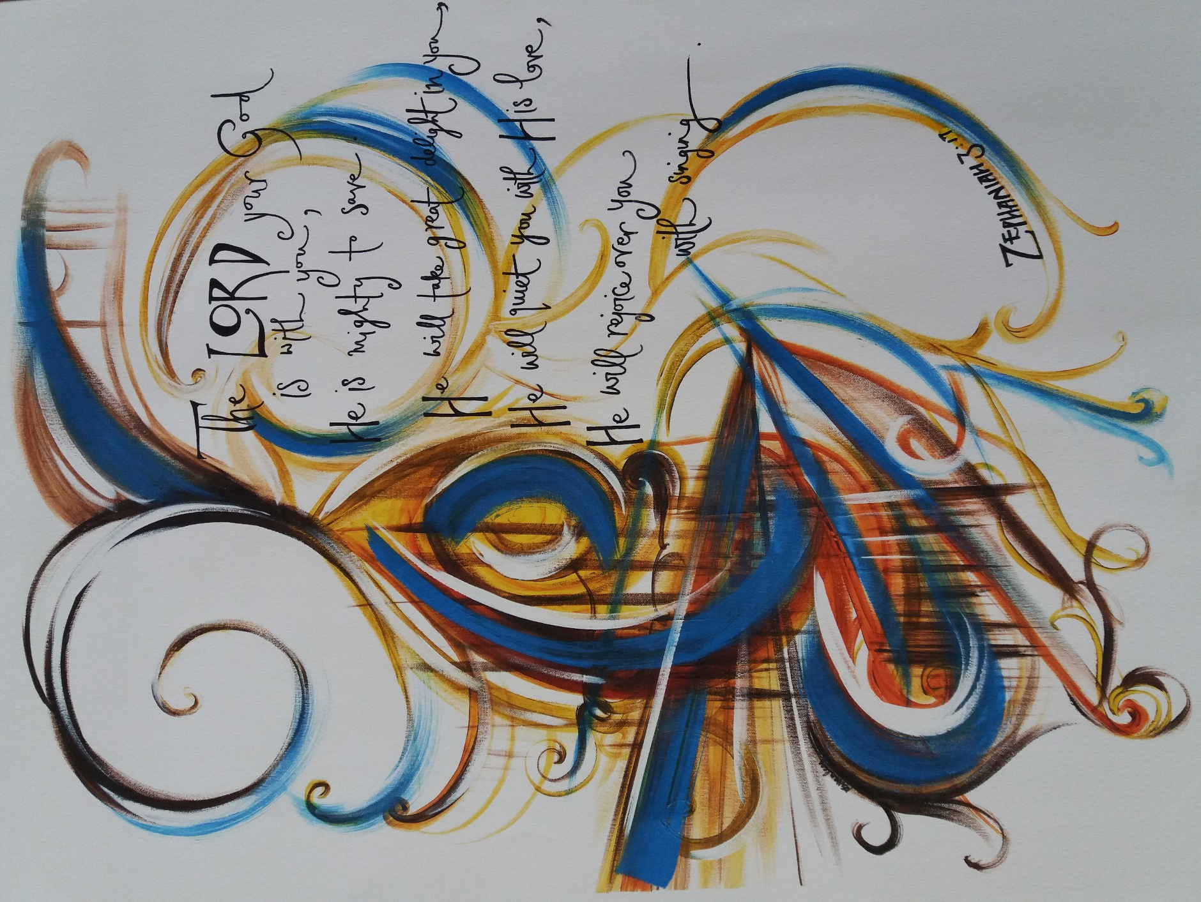
- Understanding Salvation

Introduction
Welcome to our series of studies about Growing in Faith. These notes have been prayerfully prepared for the many who are quite new to the Christian faith – perhaps following a course like Alpha or Christianity Explored or maybe through a Bible class or church service in which you made a decision to become a follower of Jesus. We hope these simple notes will help you in taking the next steps in your walk of faith so together we can ‘Grow in Faith’.
You may be studying these notes alone as private study or maybe in a group at your church – whatever it is, our prayer is that you may come to a deeper knowledge of God and to know his way for your life. Believe me, that is exciting! I have been doing just that for over 50 years and have no regrets about the decision I took at a school Christian Union film-night when I asked Jesus to come into my life. It was not ‘Job Done’ but ‘Job Begun’ and it will continue until the great day I meet the Saviour face-to-face.
This is the first of several ‘Move On’ lessons, which will follow the same format. There will be text to read, Bible verses to look up and occasionally some to memorise; all followed by questions for either private study, group discussion or to talk through with your spiritual advisor if you have one.
If you are reading these notes in an ‘on-line’ form e.g. on a computer or smart phone, you will see some texts in blue which means that that text is a hyperlink, i.e. if you ‘Click’ on the text or ‘Ctrl Click’ it, you will be taken to a site on the internet that will give you more information, possibly a song or a speaker or just more background to the subject. Make use of these as much as you can.
This first study takes us back to the message of salvation and will describe the steps that lead to someone becoming a Christian. This may help you as you ask ‘What exactly happened to me when I became a Christian?’ It may also be that you have not yet taken that step of faith and asked Jesus to become the centre of your life – there will be an opportunity for you to do that for yourself. We will move on from there step-by-step. There are seven Sessions which take the form of Question & Answer topics, but before you start them, take a few moments to pray silently to God, asking Him for His help and guidance as you go through the study.
Finally, here is our key Bible verse for this series of studies:
Therefore, as you received Christ Jesus the Lord, so walk in him Colossians 2:6
[Colossians 2:6 is called the reference and this reference says ‘this verse is taken from Saint Paul’s letter to the Colossians, chapter 2 verse 6’. You can see this verse in the on-line Bible if you point to the reference above (in blue) and use Ctrl + Click]
Question: This verse was written to people in the New Testament who had just become Christians by accepting Jesus into their lives. What do you think this verse was telling those new Christians to do?

Session 1 Does God have a plan for us and, if so, what is it?
Let’s take a look at what some others have said about life and its purpose. Following the death of the Queen, Shakespeare’s Macbeth speaks about life:
“The way to dusty death. Out, out, brief candle!
Life's but a walking shadow, a poor player
That struts and frets his hour upon the stage
And then is heard no more: it is a tale
Told by an idiot, full of sound and fury,
Signifying nothing.”
British atheist, Richard Dawkins, speaking much more recently, echoes much the same sentiment:
“The universe we observe has precisely the properties we should expect if there is, at bottom, no design, no purpose, no evil, no good, nothing but blind, pitiless indifference.”
But contrast these with what the Bible tells us about God’s plans for us:
Jesus said “For God so loved the world that he gave his only Son that whoever believes in him should not perish but have eternal life” John 3:16; and in another place he says “I came that they may have life and have it abundantly” John 10:10.
One of the best-known passages in the Bible is the 23rd Psalm which begins:
“The LORD is my shepherd; I shall not want.
He makes me lie down in green pastures.
He leads me beside still waters.
He restores my soul.
He leads me in paths of righteousness for his name's sake.
Even though I walk through the valley of the shadow of death,
I will fear no evil, for you are with me:
your rod and your staff, they comfort me”.
God’s love for us is very personal and individual. The prophet Isaiah wrote
“This is what the LORD says ‘Do not fear for I have redeemed you; I have called you by name, you are mine . . . I will be with you . . . you are precious in my eyes . . . I love you . . . ’ ” Isaiah 43:1,2

Question: What do you think it means to be personally loved by God? Is this different to simply ‘being religious’?

Question: Could God provide a better plan for your life than you could work out for yourself?

Session 2 Why do we need to be saved and, if so, to be saved from what?
Something has come between us and God – something that makes us selfish, hateful, uncaring. The Bible calls this sin and it is this that prevents us from having a perfect relationship with God and enjoying His plan for us. Moreover it is sin that will separate us from God after death and for eternity.
The Bible says “For all have sinned and fall short of the glory of God” Romans 3:23
“For the wages of sin is death, but the free gift of God is eternal life in Christ Jesus our Lord” Romans 6:23
An old hymn describes this in the following words: “Out of my bondage, sorrow and night, Jesus I come, Jesus I come . . . “ Do these words describe you? But notice there is also a marvellous hope expressed in the words above – “the free gift of God is eternal life” and “Jesus I come”. Consider carefully the illustration below to see what we mean.
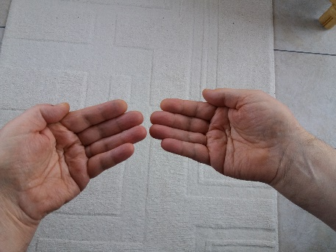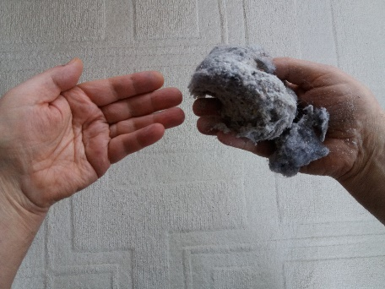
Look at the picture on the left. Now imagine the left hand in each picture represents Jesus Christ and the right hand represents you (and me). Now look at the right-hand picture – the left hand (representing Jesus Christ) is still clean but the right hand (you and me) is covered with dirt. This dirt represents sin, all those things we do wrong and are ashamed of and this sin separates us from God. The prophet Isaiah said “The Lord’s hand is not shortened, that it cannot save, or his ear dull, that it cannot hear; but your iniquities (sins) have made a separation between you and your God, and your sins have hidden his face from you so that He does not hear” Isaiah 59:1. The last book of the Bible speaks about heaven when it says “Nothing unclean will ever enter it, nor anyone who does what is detestable or false . . .” Revelation 21:27
We are defiled by sin but Jesus Christ, the Son of God, who lived a perfect life, is without sin. Saint Peter, who was with Jesus continually for three years of his life said of Jesus “He committed no sin, neither was deceit found in His mouth” 1 Peter 2:22
Question: Do you sense an uncleanness in your life that is separating you from God?
Question: How important is it that you find the way back to God?

Session 3 Can I come back into a relationship with God and if so how?
We cannot get rid of our sins by doing good works or by being religious. “(God) saved us – not by works of righteousness that we have done but according to His mercy” Titus 3:5 So are you ready for some good news? Like the best news ever in all the history of the universe?
The Bible says “Christ also suffered once for sins, the righteous for the unrighteous, that he might bring us to God” 1 Peter 3:18 and the first century church was quick to affirm this “Christ died for our sins according to the scriptures” 1 Corinthians 15:3. This is shown in the picture below where all the bad things are taken from us and laid on Jesus who paid the price for our free and full pardon so we can come back to God as if we had never sinned.
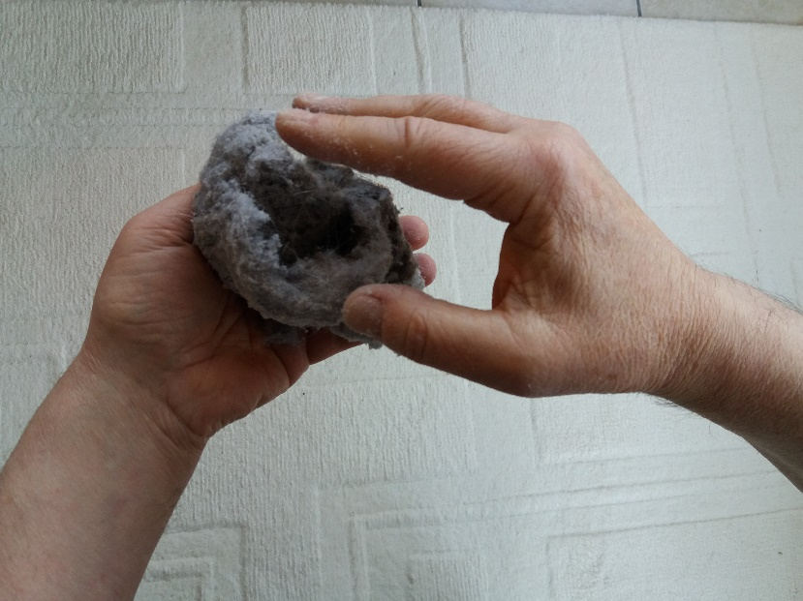
This is described in an old hymn “Oh, what a Saviour that He died for me! From condemnation He hath made me free; ‘He that believeth on the Son’ saith He, ‘Hath everlasting life’.” Click here to hear more.
The Prayer Book makes the same point ”God, who of His tender mercy did give His only Son Jesus Christ to suffer death upon the cross for our redemption made there a full, perfect, and sufficient sacrifice . . . for the sins of the whole world”
The best-known of all Christmas carols puts it like this:
“Mild He lays His glory by
Born that man no more may die,
Born to raise the sons of earth,
Born to give them second birth.
Hark the herald angels sing
Glory to the new-born King.”
He brings us a second birth – never to die (spiritually). Read what Jesus said about new birth and everlasting life in John’s gospel, chapter 3 verses 1-21.
Question: Do you agree this is the greatest news ever? Give your reasons why.

Session 4 So if God has done all this to save us, are we all automatically saved?
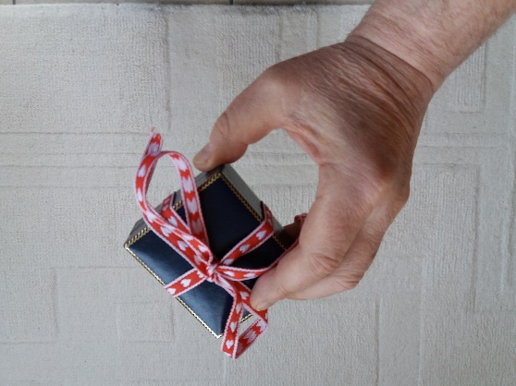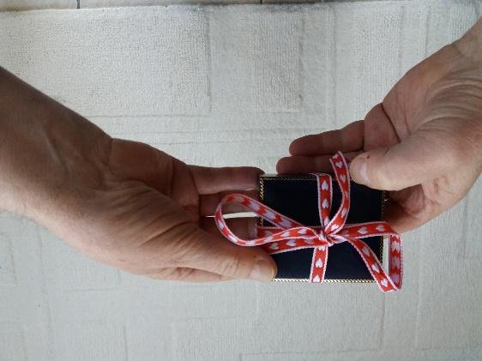
If a precious gift is offered to you, it only becomes yours if you choose to accept it. Jesus spoke about the door to our hearts “Behold I stand at the door and knock. If anyone hears my voice and opens the door, I will come in to him and eat with him and he with me” Revelation 3:20.
If you want to hear more about making this important choice, Ctrl + Click the link to listen to Dr. Billy Graham speaking in Sheffield.
Here is a prayer of acceptance you can pray right now wherever you are and whatever state your life is in.
‘Lord Jesus, I want to know you personally. I am sorry for going my own way instead of your way. Thank you for dying on the cross to forgive my sin. Please come and take first place in my life and make me the person you want me to be.’
Question: This is the most important thing you could do in your entire life – what you decide now will last forever. Have you taken this step of asking Jesus to come into your life?
Session 5 What does it mean to be a Christian and what should I do next?
Question: Did you take that important step discussed in Session 4?
Read some of the things that the Bible says will happen when you accept Jesus into your life as Saviour:
You become a new person – in the words of Jesus, you are ‘born again’ John 3:1-16
You become a child of God John 1:12
You become justified by God i.e. God, the judge, declares you ‘NOT GUILTY’ as if you had never sinned Romans 5:1
You are welcome in the presence of God forever Ephesians 2:6,7
You become indwelt by the Holy Spirit 1 Corinthians 6:19
You are made God’s heir and will inherit all the good things God has for you Romans 8:17
You enjoy God’s protection; He says He will never leave you or forsake you Hebrews 13:5
You become part of the body of believers called ‘the church’ – not merely a ‘churchgoer’ 1 Corinthians 12:13
Here are some things you can do to help you to grow and succeed in your new-born Christian life:
When you become a Christian you become a new creation 2 Corinthians 5:17 you may have to give up some of your ‘old’ ways. You may even need to say ‘sorry’ to someone, or put right something you have done wrong.
Watch the film Wire Tapper for an example of a converted gangster doing the above.
Do not be afraid to tell others you have become a Christian. Psalm 107:2
Spend time with God in prayer (be quick to confess things you do wrong, give thanks to God for His goodness and ask Him to help you and others in need) and read the Bible (God’s word). Start with a few minutes and soon you will want more.
Session 6 How can I be sure I am saved?
Memory Verse: I have written these things to you who believe in the name of the Son of God, so that you may know that you have eternal life. 1 John 5:13. Every Christian needs to know the above truth and be sure he/she is saved. So learn the above Bible verse off by heart and repeat it to yourself whenever you have any doubts.
Some years ago a famous Bible teacher was approached with this objection “Why do you say you know you have eternal life – that is being presumptuous, nobody can know”. The teacher responded by telling the objector to turn to 1 John 5:13 and to read it out, which he did. “If God says you may know” replied the teacher “are you not being presumptuous by saying you may not know?”
It is better to put your trust in the Word of God (the Bible) than to trust in faulty human reasoning or to trust in feelings which vary from day-to-day.
Here are some other Bible verses; Jesus said “Whoever comes to me I will never cast out” John 6:37 Ask yourself “What will never happen to those who come to Jesus?” and “Have you come to Jesus?” – so what can never happen to you?
Turn to John 3:36 which says “Whoever believes in the Son has eternal life”. Ask yourself, “Do you believe in God’s Son?” “So what must you have?”
John 5:24 says “Whoever hears my word and believes on him who sent me has eternal life. He does not come into judgement but has passed from death to life”. Have you heard God’s word and put your trust in Him? If so, what do you now have (present tense)? What will you not come into (future tense)? What have you passed from and into (past tense)? See how completely sure God’s salvation is! You can never be lost if you have trusted in Jesus! Listen to Living Hope (Skip the ads).
Question: Are you sure you are saved and will go, one day, to be with Jesus in heaven? On what basis?
Session 7 Where do I go next and who is there to help me?
Meet up with other Christians for mutual encouragement – if possible, read the Bible and pray together. The first generation of Christians met together regularly in homes, encouraged one another, praised God, followed the apostles’ teaching (the New Testament had not been written then), prayed together, held communion (the breaking of bread) and even took care of each other’s needs. Acts 2:41-47. A good place to start reading the Bible would be the four gospels – Matthew, Mark, Luke and John.
Christian friends, especially if some of them have been Christians for some time, would be a great place to get help – but there is even better help available . . .
Some years ago the famous evangelist, Billy Graham, was attending a lunch with many distinguished guests. Half way through the meal, he was told he was expected to give an important speech. He was completely unprepared for this as nobody told him in advance. He quietly prayed a prayer “Holy Spirit, I need your help and I need it now”. What a short prayer, but God heard and answered it. He gave his speech and it went well. We can talk to God at any time, in any situation, however briefly.
Question: Will you make it your practice to call on God in times of trouble? The writer of these notes has done this many times.
Question: What is the most important thing you have learnt from these studies?

This prayer is found in the booklet ‘Knowing God Personally’.

